## Setup

Kinova Pick Place

* move kinova_pick_place directory into : /catkin_ws/src/kinova-ros/kinova_moveit/

PCL Package

* Replace pcl_pkgs

* Compile : catkin_make

Camera Setup :

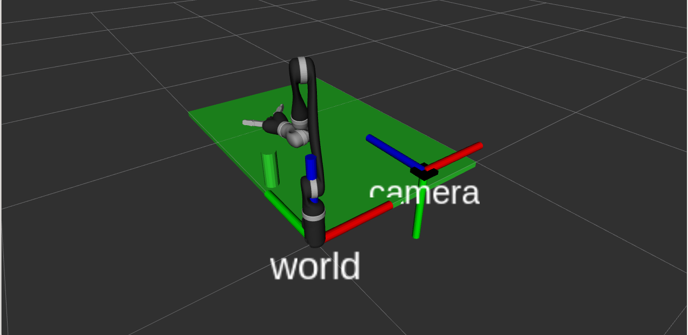

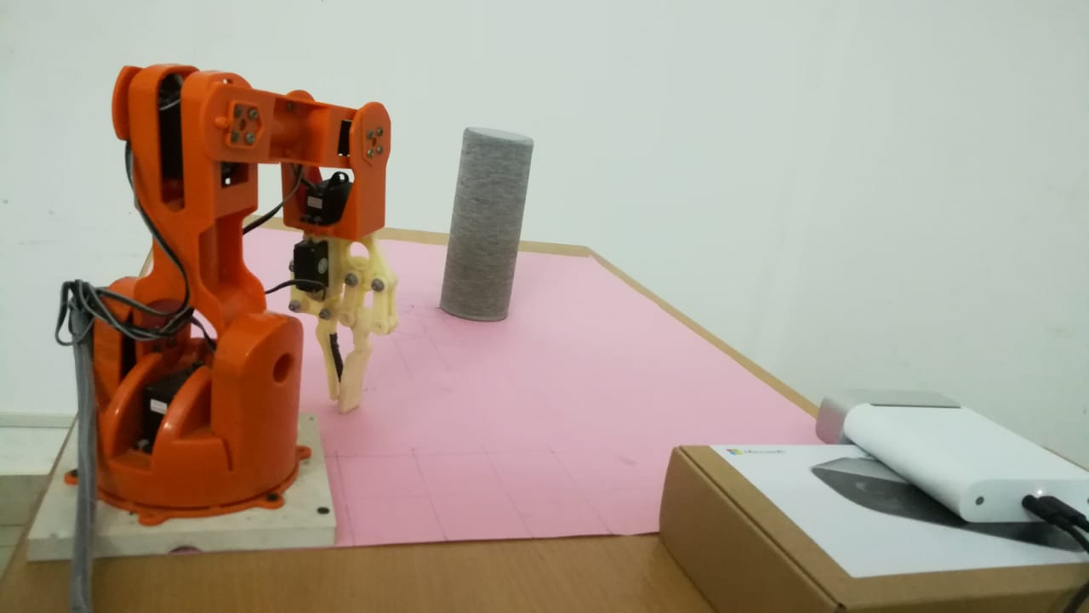

**Camera coordinates**: +x points right, +y points down and +z points forward.

**Assumed robot coordinates**: +x points right, +y points forward, and +z points up

STEPS

1.Launch Driver

roslaunch kinova_bringup kinova_robot.launch kinova_robotType:=j2s6s300

2.Moveit

roslaunch j2s6s300_moveit_config j2s6s300_robot_demo.launch

3.Launch Kinect Driver

roslaunch azure_kinect_ros_driver driver.launch depth_mode:=NFOV_UNBINNED color_enabled:=false rgb_point_cloud:=false

4. Start PCL

rosrun pcl_pkgs cylinder input:=/kinect/points2 x y z

Note: change camera topic accordingly and specify camera positions.

5. Run Pick Place node

rosrun kinova_pick_place jaco_pick_place

## Fix in gripper close action:

* Replace catkin_ws/src/kinova-ros/kinova_moveit/robot_configs/j2s6s300_moveit_config with Required Folders v0.3/j2s6s300_moveit_config
* Replace catkin_ws/src/kinova-ros/kinova_moveit/kinova_pick_place with Required Folders v0.3/kinova_pick_place
* Compile